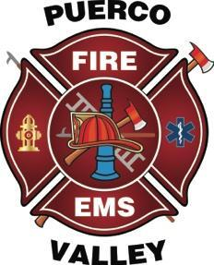
Puerco Valley Fire District

NOTICE OF EMERGENCY MEETING

The Fire Board of the Puerco Valley Fire District will meet in regular session on May 29, 2026, at 3:00 pm MST.
The meeting will be held at the Puerco Valley Fire Station in Sanders, Arizona. The meeting room will be accessible The Board may vote to go into executive session on any agenda item pursuant to A.R.S. § 38-431.03(A)(1) through (9) for legal advice with the district’s attorney on matters as set forth in the agenda. Board Members or other participants may attend by telephonic conference. The following items, topics,and any variables thereto, will be subject to Board consideration, discussion, approval, or other action. All items are set for possible action.

AGENDA

1. CALL TO ORDER / PLEDGE OF ALLEGIANCE: TIME

2. ROLL CALL OF BOARD MEMBERS AND ATTENDEES

3. New Business

- Discussion and possible action regarding the Financial status of the District

4. EXECUTIVE SESSION: TIME ___ MOTION ____ SECOND ____
Pursuant to A.R.S. §38-431.03(A), the Fire Board may go into Executive Session to receive legal advice regarding the following matters:

- Discussion and possible action regarding the Financial Status of the District

RETURN TO OPEN MEETING AT:________

ADJOURNMENT: MOTION ___________SECOND_________

